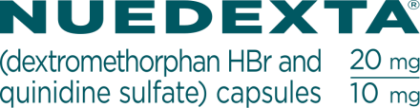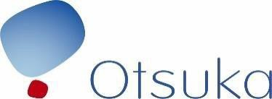

Fax completed form (no cover sheet needed) to (844) 474-0833 OR email form to OtsukaNuedexta@knipper.com. For questions, please contact customer support at (877) 930-0826.

NUEDEXTA® Sample Request Form
Shipment will contain 8 NUEDEXTA samples/bottles.

Physician Name: First : Last :

State License Number: (no abbreviations, please)

NP
DO
MD
PA

Professional Designation:

Address 1 :

Address 2 :

(check one)

Other :

City : State : Zip Code :

Phone : Fax :

Product Description:
NUEDEXTA® (dextromethorphan HBr and quinidine sulfate) Capsules | NDC Code: 64597-301-13
Size: 20mg/10mg 13 Capsules | Quantity: 8 Bottles

SIGNATURE BELOW INDICATES AGREEMENT TO THE FOLLOWING:
I certify that I am currently a licensed practitioner eligible under (1) state law, (2) my collaborating agreement and/or formulary (if applicable), to receive these NUEDEXTA samples. I have requested these NUEDEXTA samples for the medical needs of my patients and will not seek reimbursement or payment. I agree that these NUEDEXTA samples will not be traded, sold, bartered for or returned for credit and will only be used for an on-label use.
Ohio-Licensed Prescribers: The Ohio Board of Pharmacy requires this practice or facility to hold a valid Terminal Distributor of Dangerous Drugs (TDDD) license prior to accepting prescription drug NUEDEXTA samples, unless exempt under Ohio law. If you claim an exemption, you must attest that you meet one of the licensing exemptions under ORC 4729.541. Official guidance can be found at http://www.pharmacy.ohio.gov/PrescriberTDDD.

Your signature on this NUEDEXTA sample request serves as attestation that you hold a valid, appropriate TDDD license at this location or qualify under an exemption.

The information you provide on this form is subject to Otsuka’s privacy notice at otsuka-us.com/privacy-policy.

